|  |  |  |  |  |  |  |  |  |  |
| --- | --- | --- | --- | --- | --- | --- | --- | --- | --- |
| ID (PK) | Nama | Negara | Tempat_ Lahir | Tanggal_Lahir | Jenis_Kelamin | Pendidikan_Terakhir | Pekerjaan | Status_Perkawinan | EMAIL |
| 101 | Johanes | Indonesia | Medan | 21-08-1996 | Laki-Laki | S1 | Pegawai Swasta | Menikah | johanes@gmail.com |
| 102 | Eliza Dayinta Harumanti | Malaysia | Kuala Lumpur | 2-03-1990 | Perempuan | S1 | Mahasiswa | Lajang | eliza@gmail.com |
| 103 | Lukman Budi Santoso | Indonesia | Jakarta | 23-06-1983 | Laki-Laki | SMA | Pegawai Swasta | Menikah | lukman@gmail.com |
| 104 | Mohammad Fadhil | Indonesia | Jakarta | 30-03-1996 | Laki-Laki | S1 | Wirausaha | Lajang | fadhil@gmail.com |

Keterangan : ID_Pelanggan

|  |  |  |  |
| --- | --- | --- | --- |
| ID (PK) | Nama_Toko | Jenis_toko | Tahun_Bergabung |
| 201 | Toko A | Toko Baju | 2002 |

Keterangan : ID_Toko

|  |  |  |  |
| --- | --- | --- | --- |
| ID (PK) | Nama_Produk | Jenis_Poduk | Harga |
| 301 | BAJU A | Baju | 100.000 |
| 302 | BAJU B | Baju | 150.000 |

Keterangan: ID_Produk

Keterangan : ID_Transaksi

|  |  |  |  |  |  |  |  |
| --- | --- | --- | --- | --- | --- | --- | --- |
| ID (PK) | Nomor_Transaksi | ID_Produk | Jumlah | Harga | ID_pelanggan | ID_TOKO | Waktu_Pembelian |
| 401 | 50001 | 301 | 2 | 200.000 | 101 | 201 | 9-01-2022 |
| 402 | 50002 | 301 | 1 | 100.000 | 102 | 201 | 10-01-2022 |
| 403 | 50003 | 302 | 1 | 150.000 | 103 | 201 | 13-01-2022 |
| 404 | 50004 | 302 | 2 | 300.000 | 104 | 201 | 13-01-2022 |

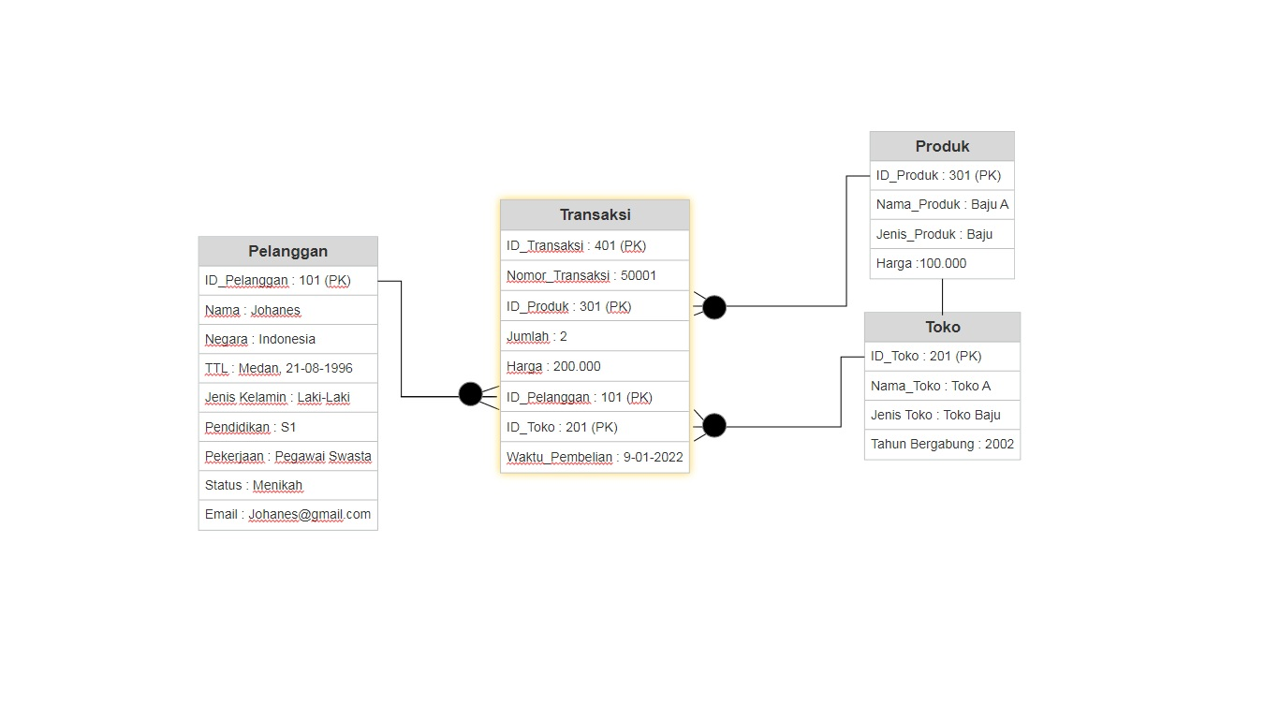

ERD TRANSAKSI 1

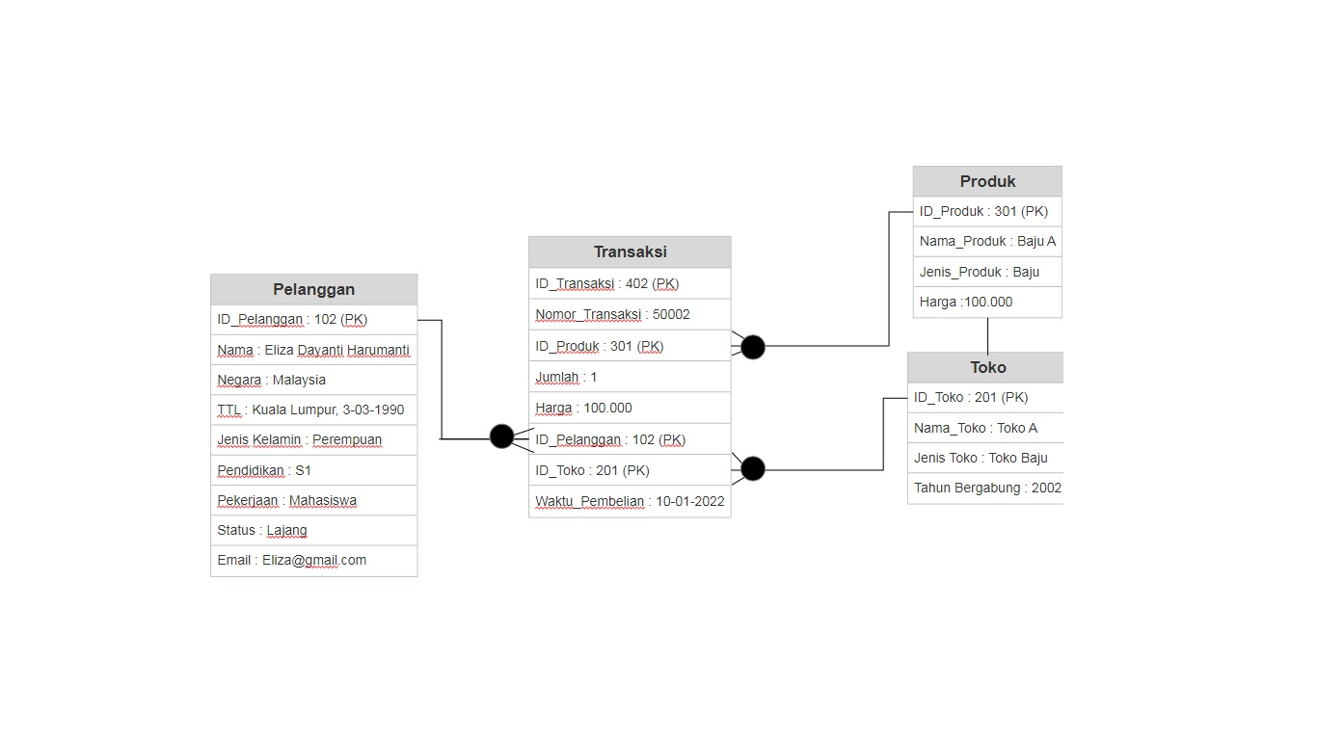

ERD TRANSAKSI 2

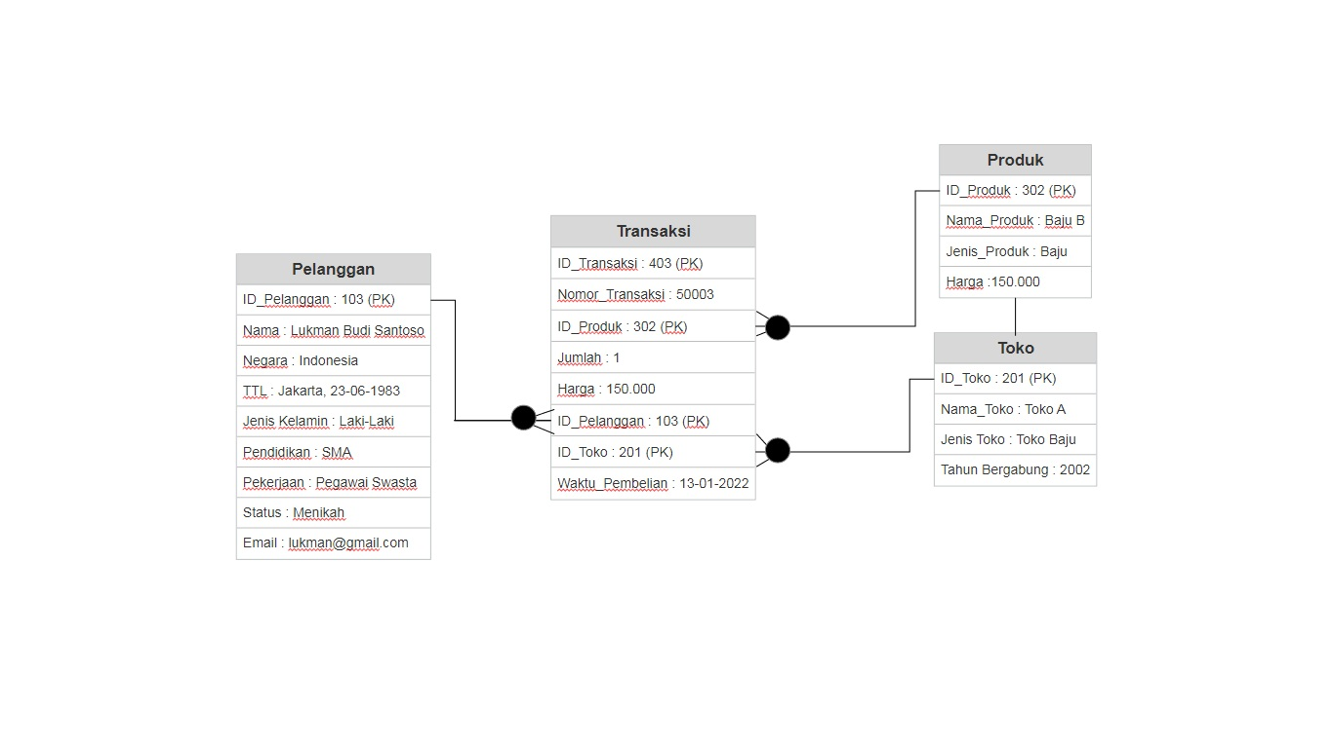

ERD TRANSAKSI 3

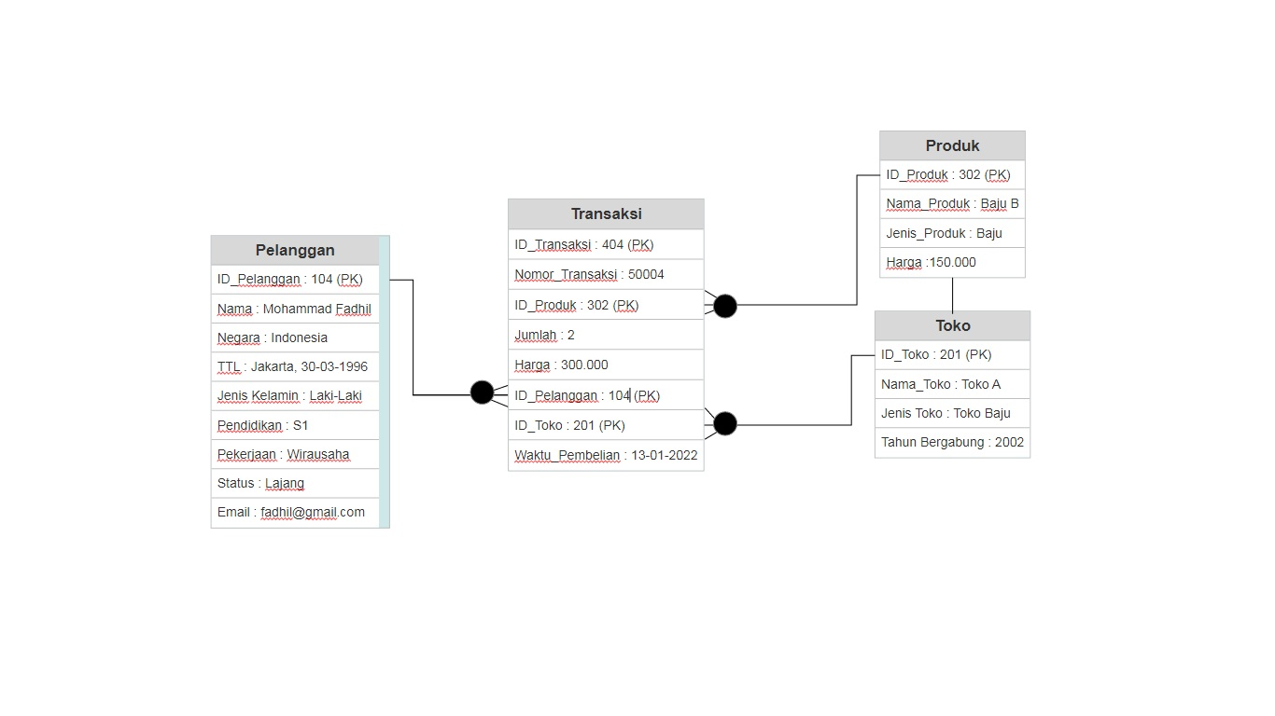

ERD TRANSAKSI 4

TRANSAKSI 2